

**Draft System Analysis Phase Report**

**Client: Trace3**



**BUDT723**

**Business Process Analysis**

**Capstone Project**

Team Members (under the guidance of *Dr. Paul Shapiro*):

* Farah Bushra (primary POC)
* Harshil Patel (secondary POC)
* Siddharth Khare
* Asheer Mogal
* Pranay Reddy Anthireddy
* Niharika Gupta
* Pradyum Mohta

Document last edited on: 04-07-2024

**CLIENT AND INDUSTRY BACKGROUND**

Trace3, founded in 2002, is a technology consulting company headquartered in Irvine, California, that provides IT strategy, solutions, and services to organizations around the globe. Trace3 has continued to work on delivering cutting-edge services to companies seeking to navigate the dynamic IT landscape and maintain a competitive edge.

With collaboration with top technology names like Cisco, Dell Technologies, and Microsoft, Trace3 has ensured it provides only the best-in-class solutions that are specifically tailored to its customers' needs. With a team of experienced consultants and engineers, Trace3 provides impactful solutions that drive growth and business value.

**PROBLEMS, OPPORTUNITIES AND DIRECTIVES**

**Challenges:**Some of the challenges that are associated with this project are as follows:   
The current system has a semi-optimal quality of resource allocation and meeting scheduling  
- An iterative feedback loop regarding meetings

- Keeping track of the attendance of participants in meetings

- Datasets from Trace3 are required to tune our systems as per requirements. The data may be proprietary and there may be rules and regulations that need to be followed

- Clear communication of the agenda before the meeting begins

- Checking if the agenda of the meeting was met

**Opportunities:**

- There is scope to make human resource allocation more efficient and streamlined. This will help in better time management

- Create a summary of each meeting to analyze the progress of the project.

- Make a more efficient system for Trace3 to manage their progress on different projects.

- Reminding participants about the scheduled meetings so they don't miss

- Avoiding unnecessary inclusion of employees who are involved in the high priority meets/tasks

**Directives:**

- The best design and development practices are required to be followed while creating the platform. This will also be by the compliance rules that Trace3 has set.

- The product design has to be according to the bylaws of the company

- All rules and regulations related to data-storing, record-keeping, and analysis have been followed according to what the company has set.

- Priorities will need to be given to some features of the platform which will represent the priorities in our development.

**PROJECT SCOPE**

The project will develop an effective meeting assistance tool tailored for Trace3's strategic initiative meetings. This tool integrates meeting progress tracking, categorizing time by project, and generating insightful reports and dashboards for management review. Enhanced features will include action item reporting, meeting reminders, and integration with meet scheduling tools. Please find some of the key features:

* **Dashboard Analytics:** The tool will generate reports showing the meeting progress, meeting summary, and meeting attendees; broken down by department, project, meeting, and attendee, offering comprehensive insights into resource utilization.
* **Meeting Summary Report:** As a primary requirement from Trace3, the tool will focus on accurately generating reports for each strategic meeting.
* **User Base:** The initial users of the system will include internal Strategic Initiatives (SI) team members like Project Managers (PMs) ensuring that the tool meets the specific needs of those directly involved in strategic project planning and execution.
* **Integration with Smartsheets:** The tool will be designed to integrate seamlessly with Smartsheets, allowing for the synchronization of meeting insights, action items, meeting summary notes etc. with existing project management workflows.

**PROJECT OBJECTIVE**

Develop and implement a comprehensive meeting management tool for Trace3 by November 2024 (tentative), streamlining the entire meeting lifecycle from pre-meeting planning to post-meeting follow-up. The tool will include scheduling, agenda creation (manual), document sharing, note-taking/summarizing/tracking unanswered questions (if time permits), task assignment, and analytics. Success will be measured by widespread adoption, reduced preparation time, positive user feedback on improving productivity and decision-making, and the use of analytics for data-driven insights. The tool will seamlessly integrate with Trace3's existing technology stack, including Smartsheets, Calendar, and video-conferencing tools (Zoom/Google/WebX).  
  
**HIGH-LEVEL REQUIREMENTS**

1. Development of a core meeting analysis and utilization reporting tool/dashboard. Integral analysis and resource utilization reports can be viewed here.
2. The business processes related to the meeting will be done in three sections: pre-meeting, in-meeting, and post-meeting.
3. The tool needs to be able to assist Trace3 in meeting processes such as scheduling, task creation and assignment, resource sharing, etc, as well as analyze the meeting proceedings and usage of resources.
4. Integration capabilities with the existing project management software - Smartsheet. This will create a centralized place where all data related to a meeting (inside an ongoing/completed project can be viewed).
5. Includes updations in data flows between different processes. Plus, updations in their data security and privacy protocols.

**PROJECT CONSTRAINTS**

Based on the constraints provided, here's how the project constraints may look from both the client side and the development team side:

Client-side constraints:

* **Limited Data Sharing due to Privacy**: The client may restrict the amount of data that can be shared externally due to privacy concerns. This constraint may impact the development team's access to certain data for testing or integration purposes.
* **Integration with Existing Systems**: The project requires integration with existing systems such as smartsheets, outlook etc. This constraint means that the development team needs to ensure seamless integration while respecting the functionalities and limitations of the existing systems.
* **Adherence to Regulatory Standards and Compliance**: The project must adhere to regulatory standards and compliance requirements, which can impact the development process and dictate specific security and privacy measures that need to be implemented.

Team-side constraints:

* **Well-Defined Project Scope**: The development team must work within a well-defined project scope to ensure that all deliverables can be completed within the designated timeline of 6 months.
* **Budget-Conscious Resource and Technology Usage**: Resources and technologies will be thoughtfully used to keep the project within budget constraints. This means the development team must prioritize cost-effective solutions and avoid unnecessary expenses.

**NEXT-STEPS FROM OUR END**

1. We have already begun work on the next phase (design phase) deliverable. Expectations for completion of the deliverables lie in the next week.
2. Holding recurring meetings with representatives at Trace3 for iterative feedback sessions. Keep up the recurring meetings we are conducting with Trace3. Lindsey and Ellen from Trace3 have already indicated their availability on each Friday for feedback and update meetings. This will enable us to keep them in the loop with developments that are being done by our team.
3. Gathering more information and facts related to the new proposed system.
4. Creating a DFD (data flow diagram, using Visible Analyst software) and ERD (entity relationship diagram, using LucidChart software) that depicts the data flows, business processes, data stores etc. of the proposed new meeting management system at Trace3.
5. Consult with Prof. Shapiro during his office hours. We’ll receive his feedback and incorporate them into our deliverables.
6. Resolving any questions and concerns that the team may have regarding the Phase 2 and future Phase 3 tasks.

—-SOW End—--

**Description of the fact findings and information-gathering techniques used in studying the current systems:**

For studying the current information systems used by Trace3, we have used the following techniques:   
  
A. Scheduling recurring meetings with the strategic initiative team at Trace3 (Ellen Edgington and Lindsey Little) on video conferencing. The meeting involved us asking questions about their current systems and where they would like to see improvements. This enabled us to ascertain the proper requirements of Trace3.

Profiles of the strategic initiative team:

<https://www.linkedin.com/in/ellen-edgington-psm-safe%C2%AE-5-certified-agilist-70a0495>  
<https://www.linkedin.com/in/lindsey-jackson-little>

B. Getting the SOW drafts and related deliverables reviewed by Trace3. This step ensured alignment with Trace3's expectations, with iterative adjustments made based on their feedback.

C. Continuous communication established through email via our point of contact (Farah) with Trace3's strategic initiative team. This helped us keep track of any changing requirements.

D. In addition to the continuous communication with Trace3, we also consulted with Prof. Shapiro to cross-check the drafts and other deliverables created by us.

**Visible Analyst Project Name:** GROUP1_0501_TRACE_CURRENT SYSTEM

**DFD:**Context Diagram:   
  
  
  
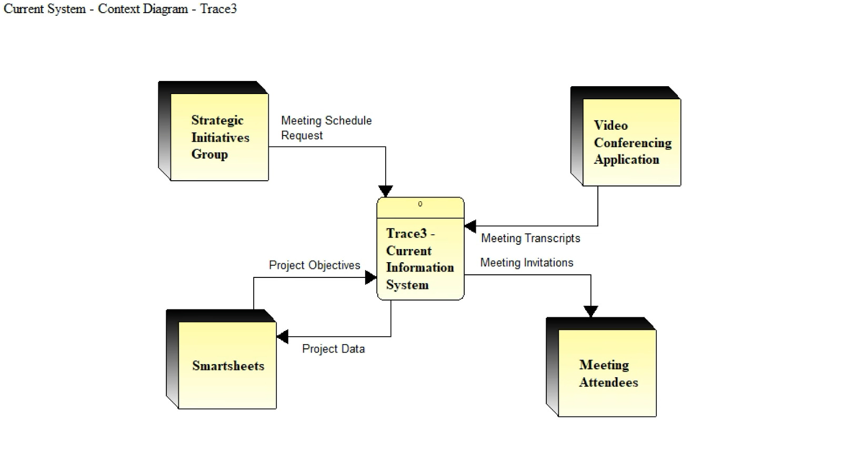  
  
  
  
  
  
  
  
  
  
  
  
  
  
  
  
  
  
Level 0:   
  
  
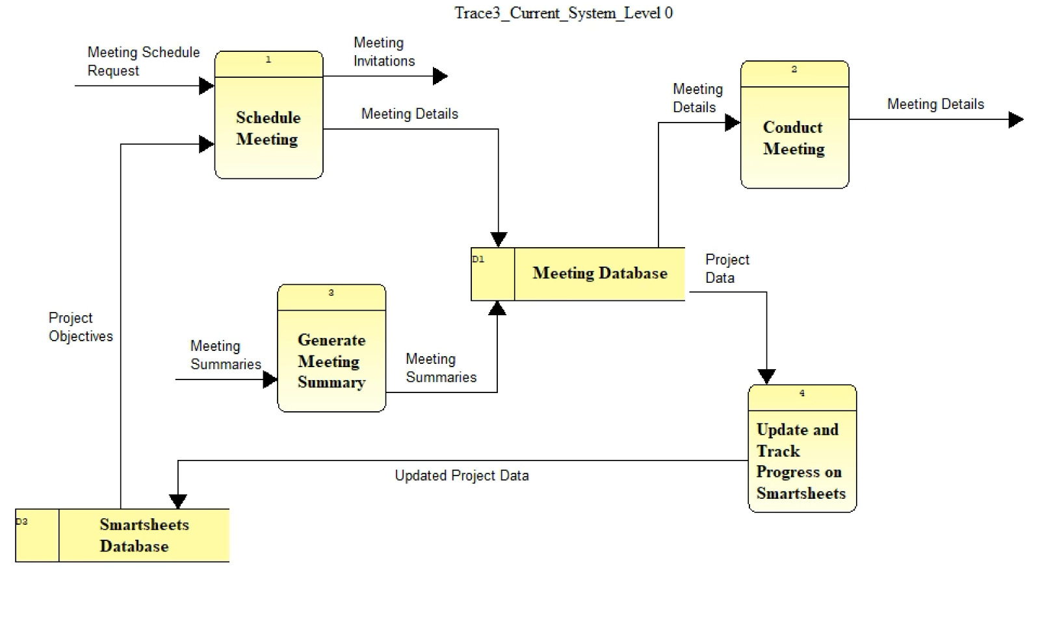

Level 1:   
  
  
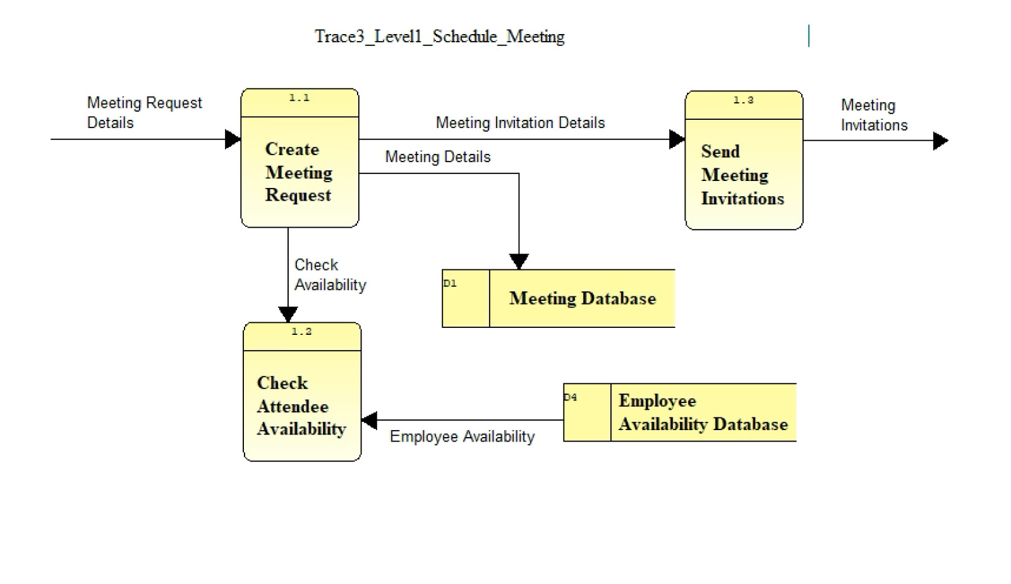  
  
  
  
  
**Visible Analyst Project Name:** GROUP1_0501_TRACE_CURRENT SYSTEM

**Entity Relationship Diagrams (ERD):**  
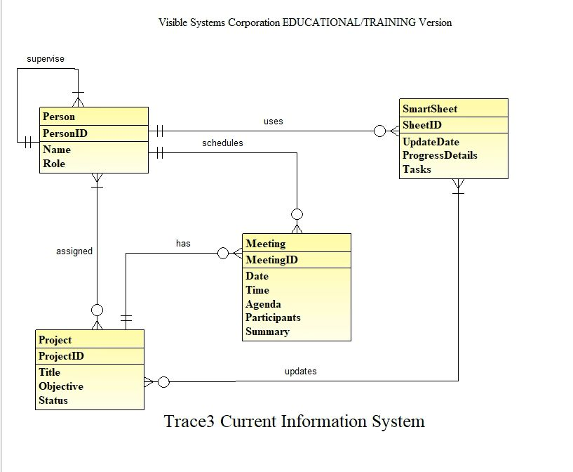

About ERD:   
  
The above ERD displays the relationships and entities in the current meeting management and scheduling system at Trace3 is a manual solution that tries to integrate with external productivity tools like Zoom and Smartsheets.

An organizer can request a meeting by checking Employee Availability on their scheduler (Outlook) to ensure attendee availability. Once scheduled, finalized meeting details are stored in the Meeting Database, and invitations are sent out accordingly.

During meetings, the system utilizes Zoom’s closed captioning feature to generate captions of the whole meeting. The organizer of the meeting then manually updates the smartsheet of that particular meeting on the ongoing project.

—------